**Final Display**

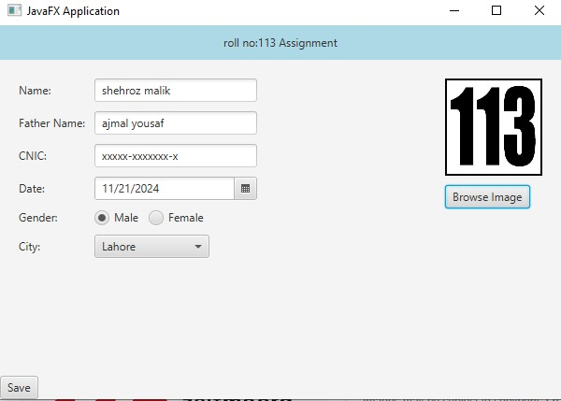

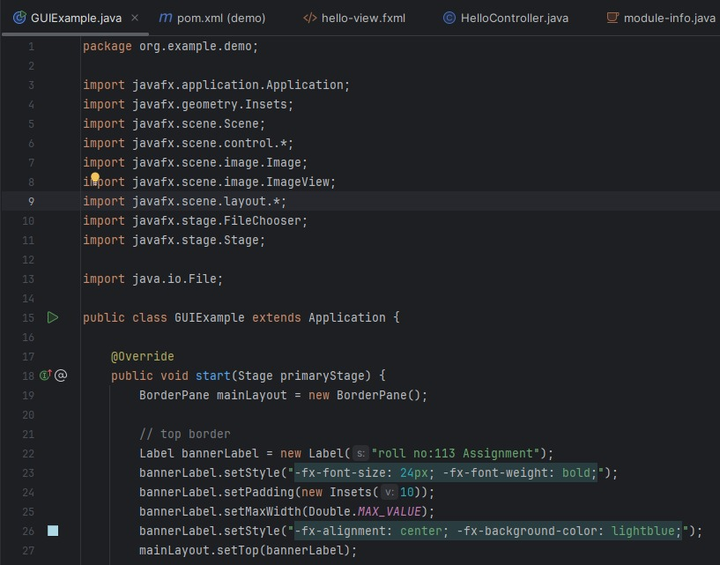**Code**

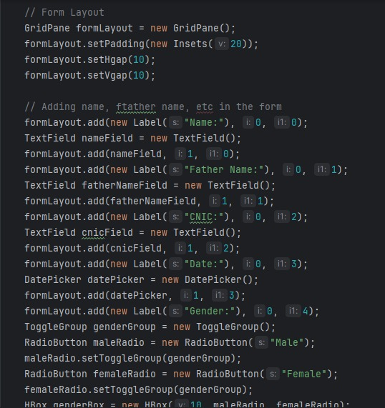

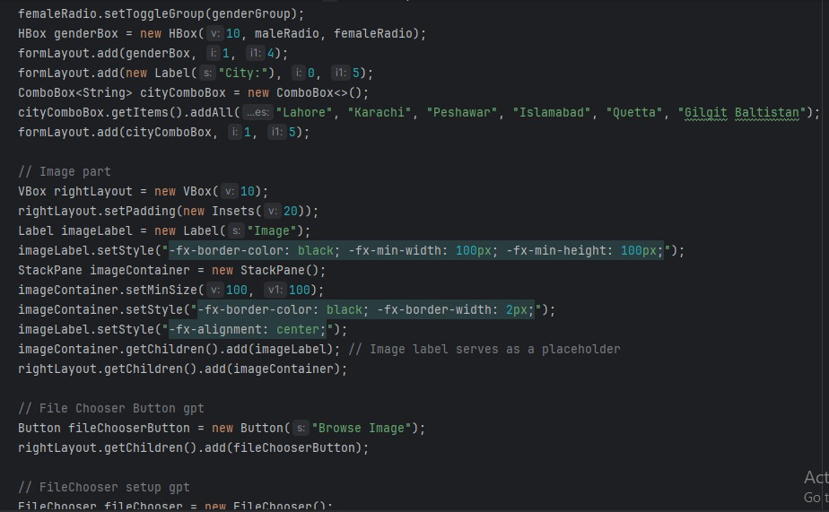

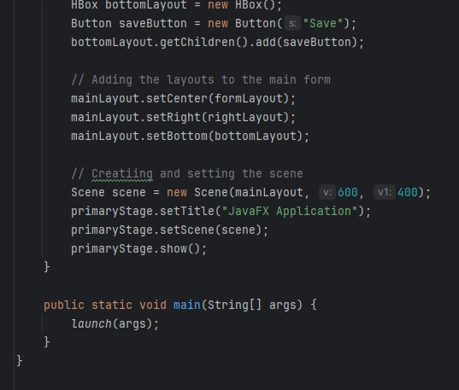

**Documentation:**

* Labels (Label): Used to display text (e.g., "roll no:113 Assignment", "Name:", "Father Name:", etc.).
* Text Fields (TextField): Used for input fields where the user can type in information (e.g., "Name", "Father Name", "CNIC").
* Date (Date): for selecting a date.
* Radio Buttons (RadioButton): Used for gender selection ("Male", "Female").
* Combo Box (ComboBox): A drop-down menu for selecting a city.
* Buttons (Button): Used for various actions, such as saving information or browsing for an image file.
* File Chooser (FileChooser): A dialog that allows users to select an image file.
* Image (Image) and ImageView (ImageView): Used to display an image chosen by the user.

**3. Layouts**

* BorderPane
* GridPane
* HBox
* VBox
* StackPane

**4. Event Handling**

**Set on Action:** Used to define the behavior when a button (such as the "Browse Image" button) is clicked.

**File Chooser:** allows the user to choose an image file.